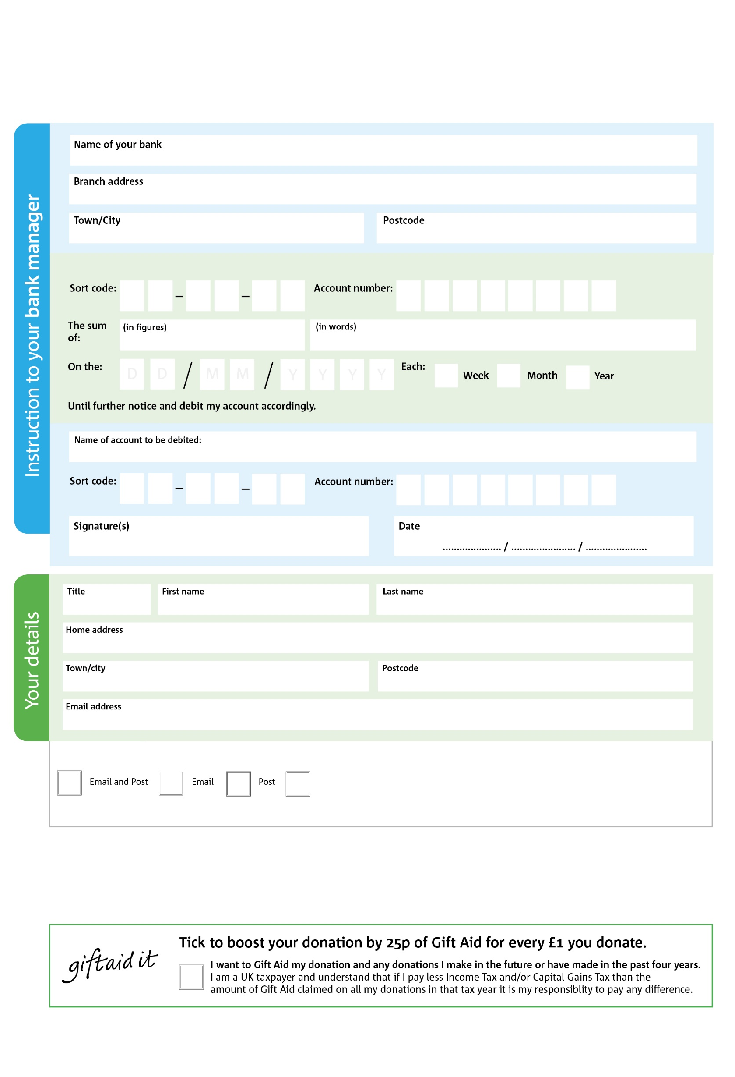007

**Data protection**

Newcastle East Foodbank is committed to protecting your privacy and will process your personal data in accordance with the Data Protection Act 1998. Newcastle East Foodbank collects information to keep in touch with you and supply you with information relating to our work.To unsubscribe to our newsletter from our newsletter, send a message to the email address above with the word, ‘unsubscribe’ in the subject line A full data privacy statement for financial donors is available from the foodbank on request.

9

V

0 0

V

8 7

Please pay EFGA Dream Centre Community Projects (Foodbank)

POSTAL ADDRESS: Newcastle East Foodbank,Elim Church at the Dream Centre Heaton Road, Newcastle upon Tyne, NE6 1SB

Reg.CharityNo.251549

**Please pass this form onto the foodbank, using the foodbank’s address at the bottom, who will save a copy for their records. They will then send it onto your named bank or building society.**

0

V

1

V

9

V

1

V

9

V

1

9

0

3

We would love to keep you up to date with information about Newcastle East Foodbank. Please tick your preference:

You can change your preferences any time by contacting us on 0191 2242422 or emailing us at foodbank@elimnewcastle.org.uk

I do not wish to receive future communications from Newcastle East Foodbank

**Standing Order Mandate**

**newcastleeast.foodbank.org.uk**

Reg. Charity No: xxxxxx | Reg. in England & Wales

You can change your preferences any time by contacting us on XXXXXXXXXXX or emailing us at XXXX@XXXXXXXXXX.foodbank.org.uk

I do not wish to receive future communications from XXXXXX Foodbank