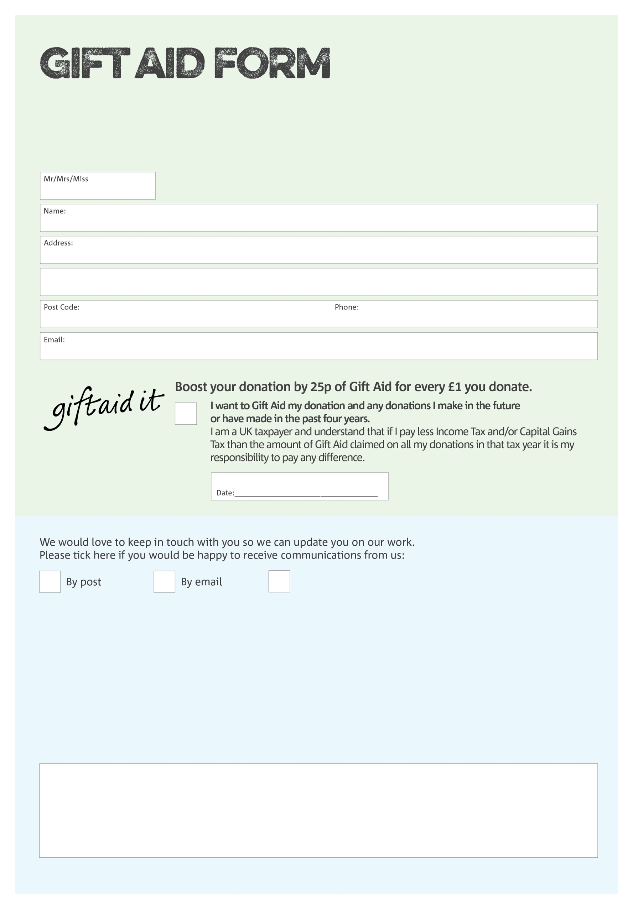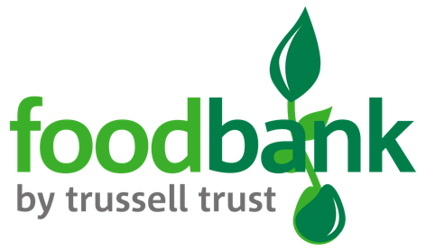

By filling in this form Newcastle East Foodbank will receive an extra 25p for every £1 you give at no extra cost to you. Thank you!

You can change your preferences any time by contacting us on 0191 2242422 or emailing us at

foodbank@elimnewcastle.org.uk

I do not wish to receive future communications from Newcastle East Foodbank

**Data protection**

Newcastle East Foodbank is committed to protecting your privacy and will process your personal data in accordance with the Data Protection Act 1998. Newcastle East Foodbank collects information to keep in touch with you and supply you with information relating to our work. Newcastle East Foodbank will never sell or pass your details to anyone who isn’t directly working on our behalf.

We would love to know why you have chosen to donate to Newcastle East Foodbank. If you would like to share your motivation let us know below:

Charity Number 251549. Registered in Eng. & Wales